SOFT [ware] Buttons:

<SAVE>

Save record with modifications to the database tab of the workbook.

<MODIFY>

Loads the data from the database tab into the form tab for modification or update.

<DELETE>

Removes the record from the database. (Has been disabled)

<RESET>

Clears the screen.

To perform Reporting… pick what Barcode number you are auditing, *this is done outside of this APP*.

1. Select the <FORM> tab.
2. Select <MODIFY> soft button

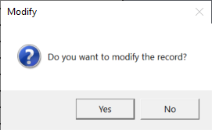

1. Select <YES>

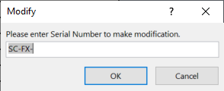

1. Enter ‘Barcode Number’ in dialog box

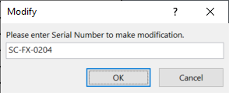

1. Select <OK>
   1. Form data will populate from Database

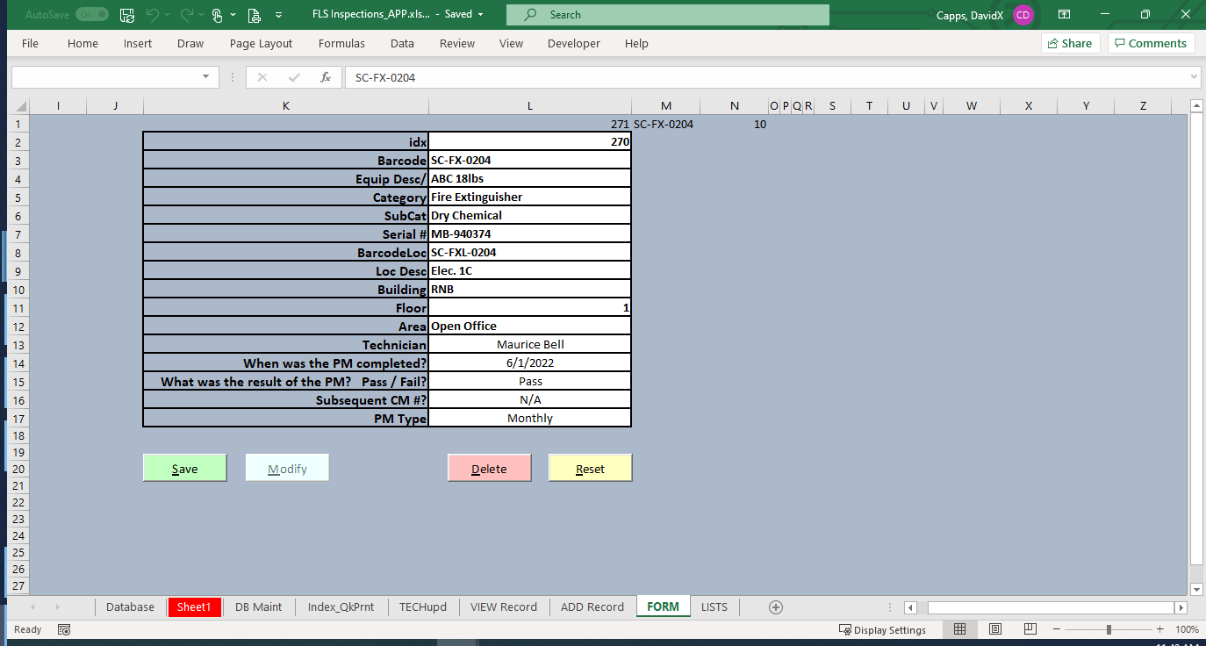

1. Inspection Information will need to be filled in or confirmed
2. When audit/update is complete, select the <SAVE> soft button
   1. Validation code will attempt to prevent errors from being entered into the database.

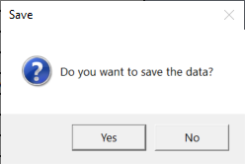

Cells in the database record editable by formula or macro:

1. idx
2. Barcode
3. Equip Desc/
4. Category
5. SubCat
6. Serial #
7. BarcodeLoc
8. Loc Desc
9. Building
10. Floor
11. Area
12. When was the PM completed?
13. What was the result of the PM?   Pass / Fail?
14. Subsequent CM #?
15. PM Type